**Authentication Validation**

TC_001: Valid Authentication

Scripts:

* Response Validation
* Status Code Validation
* Response Body Validation

TC_001: InValid Authentication

Scripts:

* Invalid Credentials
* Username/pass missing
* Response Validation
* Status Code Validation
* Response Body Validation

**User Testing**

TC_001: Get all users

TC_002: Get a specific user

TC_003: Get a non-existing user “/user/400”

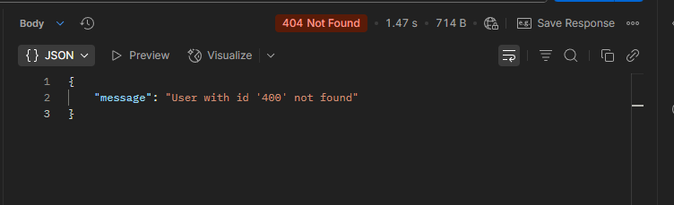

TC_004: Get all users without Authroization

**Product Testing**

TC_001: Get all Products

TC_002: Search product

Scripts:

* Response Time Validation
* Response Validation
* Status Code Validation
* Response Body Validation

**Cart Testing**

TC_001: Get cart by ID

TC_002: Get all carts

TC_003: Add to carts